

Atlantic Coastal Cooperative Statistics Program
1050 N. Highland Street, Suite 200A-N | Arlington, VA 22201
703.842.0780 | 703.842.0779 (fax) | www.accsp.org

Atlantic Coastal Cooperative Statistics Program Operations/Advisory Committee
Minutes
July 17, 2025, 1pm – 3pm
Webinar: https://v.ringcentral.com/join/229731989
Calendar Link: https://asmfc.sharefile.com/public/share/web-s9d612bfc00e24a7ab61d004db00f0cf4
DRAFT MEETING MINUTES

Name | Partner | Phone | Email
Julia Beaty | MAFMC |  | jbeaty@mafmc.org
Julia Byrd | SAFMC | (843)-302-8439 | julia.byrd@safmc.net
Nicholas Buchan | MA DMF |  | nick.buchan@mass.gov
Pat Campfield | ASMFC |  | pcampfield@asmfc.org
Claire Fitz-Gerald | NOAA |  | claire.fitz-gerald@noaa.gov
Elizabeth Gooding | SC DNR |  | goodinge@dnr.sc.gov
Maryellen Gordon | NJ DFW | (609) 748-2020 | maryellen.gordon@dep.nj.gov
Dave Gloeckner | SEFSC |  | david.gloeckner@noaa.gov
Nicole Lengyel Costa | RI DFW |  | nicole.lengyel@dem.ri.gov
Dee Lupton (Chair – Advisors) |  |  | soulrebel@centurylink.net
David McCarron | NEFMC |  | dmccarron@nefmc.org
Brad McHale | NOAA |  | brad.mchale@noaa.gov
Story Reed (Chair – Operations) | MA DMF | (978)-282-0308 | story.reed@state.ma.us
Adam Rettig | NOAA |  | adam.rettig@noaa.gov
Stephanie Richards | MD DNR |  | stephanie.richards@maryland.gov
Rob Watts | ME DMR | (207)-633-9412 | rob.watts@maine.gov
Catherine Wilhelm | VMRC |  | catherine.wilhelm@mrc.virgina
Greg Wojcik | CT DEP |  | gregory.wojcik@ct.gov

Committee Members Not in Attendance: M. Barrow (NY DEC), I. Braun-Ricks (PRFC), Julie Califf (GA DNR), Joshua Carloni (NHFGD MARINE FISHERIES DIVISION), Lauren Dolinger Few (NMFS-HQ MRIP), Gary Glanden (DE DFW), Francine Karp (RI – R/C), Michael Larkin (NOAA), Alyssa Lefebvre (NY DEC), Stephanie McInerny (NCDMF), J. Morgan (CT-REC), R. Mroch (NOAA)

Others in Attendance: Angela Giuliano (MD DNR), Jesse Hornstein (NY DEC), John Maniscaslco (NY DEC), Ronald Owens (PRFC), Jason Walsh (NCDMF), Anna Webb (MA DMF)

Staff Members in Attendance: J. DeFilippi Simpson (Deputy Director), G. White (Director)

Welcome and Introductions
Chairs S. Reed and D. Lupton welcomed everyone to the meeting.

Review and Approve Agenda
The agenda was approved with no changes.

Public Comment
There was no public comment.

Review FY25 Preliminary Proposals (S. Reed)
J. DeFilippi Simpson gave an overview of the process. Each proposal will be covered, and time allowed for committee members to note areas for change or ask questions of PIs. All feedback will be recorded and sent to PIs for consideration during revisions.

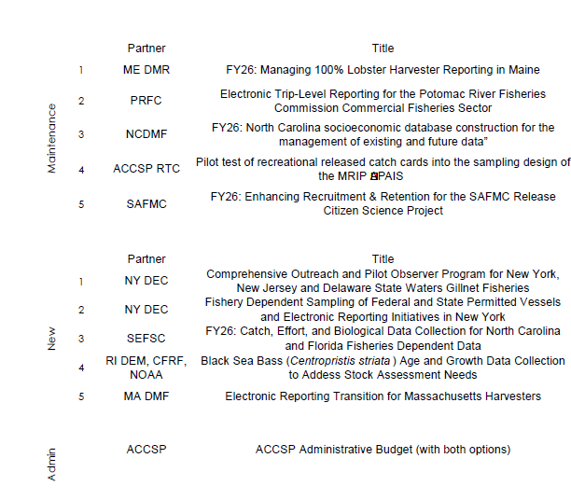

Maintenance
FY26: Managing 100% Lobster Harvester Reporting in Maine

Reports up to date. Budget question: The fringe costs are often the same or more than the salary, which seems odd. Noted on page 33: to please check the in-kind calculation.

Electronic Trip-Level Reporting for the Potomac River Fisheries Commission Commercial Fisheries Sector

No 2024 annual or semi-annual reports. No questions or comments.

North Carolina socioeconomic database construction for the management of existing and future data

No reports are due yet because of funding distribution timing. No questions or comments.

Pilot test of recreational released catch cards into the sampling design of the MRIP APAIS

No reports are due yet because of funding distribution timing. No questions or comments.

Enhancing Recruitment & Retention for the SAFMC Release Citizen Science Project

No reports due yet because of funding distribution timing

Questions
Is biological the appropriate priority?

The PI responded, while the focus is on released fish, the data collected is lengths which have been seen as the biological priority. This proposal was also biological last year, and all previous Release proposals have been biological. Some individuals see this as potentially a bycatch proposal.

It was recommended for the PI to please include this response in the updated proposal.

New

Comprehensive Outreach and Pilot Observer Program for New York, New Jersey, and Delaware State Waters Gillnet Fisheries

It was noted on page 190 the cost of measuring board is double what the SEFSC board costs. It was noted the match is well described in the budget narrative but is not shown on the table.

Page 193 was referenced; the budget includes an ASMFC/ACCSP Indirect overhead. This has never been included until this year. The PI responded that the intention is that these funds will go to CCE from ASMFC rather than through NY. The indirect rate was provided by Geoff White.

It was recommended for the PI, to please include this response in your updated proposal.

It was noted the results and benefits section needs more elaboration on bycatch/species interactions the project would benefit.

It was asked how does the catch and effort data that will be collected through observers be different from the data collected from harvesters.

It was noted the timelines could be an issue depending on federal distribution

Page 187 was referenced, please also note how many trips/week this comes out to.

Within the Budget, please provide what each staff member is going to be doing and provide percentages of salary.

Be mindful of the scale and measuring board. There isn’t a lot of room on the vessels.

Noted that RI believes that less staff can achieve 2% coverage.

Is it possible to see if NEFOP has datasets that could be compared.
The PI responded the states have secured datasets from NEFOP. Some manipulations would have to be done but a comparison could be done. PI please include this response in your updated proposal.

Fishery Dependent Sampling of Federal and State Permitted Vessels and Electronic Reporting Initiatives in New York

Page 217 was referenced. It was noted ACCSP should be covering the cost of iPads for select members of industry. In the budget that's $22,875 not including the extra for indirect.

Page 218 was referenced there was mention of utilizing the ACCSP help desk. Will this be an option?

Page 221 was referenced. The budget includes an ASMFC/ACCSP Indirect overhead. It was noted this was never seen or included until this year.

Page 222 was referenced. The cost of measuring board is double what the SEFSC board costs. It was asked if they were the same or not.

Page 225 was referenced. Questioning the transition plan as it just indicates it's going to grow bigger.

Table 1 lists the priority species, but some of these already have mandatory sampling through the FMP

Questions
How can you determine the staff support needed if you don’t have targets?

Please provide estimates of the number of individuals that will be moving to electronic reporting

For the budget it was noted to please provide what each staff member is going to be doing and provide percentages of salary.

FY26: Catch, Effort, and Biological Data Collection for North Carolina and Florida Fisheries Dependent Data

Please provide a letter from NC that commits to housing the personnel in the state.

The PI responded that there are going to be significant changes to this proposal. We will likely be adding North Carolina and Florida as a submitting partner. Also switching from using federal contracting to using state contracting. Note that these changes will change the budget, lower personnel costs, but increase in supplies and such. This is estimated to be potentially about $30,000 in increase. PI please include this response in your updated proposal.

It was noted the CVs are only supposed to be 2 pages/person.

Page 244 was referenced. It was noted to provide more details on the approach.

Questions
What proportion of past sampling is going to be addressed through this project?
The PI responded that the intent is to get back to the level of sampling in January 2025. We can include what was occurring and what we intend to maintain. PI please include this response in your updated proposal.

For the budget please provide what each staff member is going to be doing and provide percentages of salary.

Black Sea Bass (Centropristis striata) Age and Growth Data Collection to Address Stock Assessment Needs

For the budget section please provide what each staff member is going to be doing and provide percentages of salary.

Electronic Reporting Transition for Massachusetts Harvesters

ACCSP will be providing a memo of minimal to no impact on staff and operations.

Within the budget please provide what each staff member is going to be doing and provide percentages of salary.

Administrative

ACCSP Administrative Budget

Noted that the IRA funding has been rescinded so G. White and J. DeFilippi Simpson will be considering options in the coming days. It is uncertain whether this will have any impact on the administrative budget.

Next Steps (i.e., deadline for sending additional comments, comment review)
- Week of July 21: Feedback submitted to PIs
- August 15: Revised proposal deadline
- Week of September 8: Preliminary Ranking Exercise
- September 23-24: Joint Meeting (proposals are ranked)

Other Business
September Joint meeting planning was discussed. It is unlikely that the federal government will allow travel so the meeting will have to have a hybrid format. The group discussed that others would have to commit to in-person attendance in-order to have a successful meeting. Everyone committed to attending and agreed that Portsmouth, NH was a good venue. D. McCarron offered to assist with locations and AV support. D. Gloeckner noted that federal travel has been eased somewhat so he is planning on attending the meeting.

J. DeFilippi Simpson noted that A. Rettig had reached out this morning to confirm allocations for the FY25 funding, which should be released soon.

Adjourn
The meeting was adjourned at 3:06 pm.

